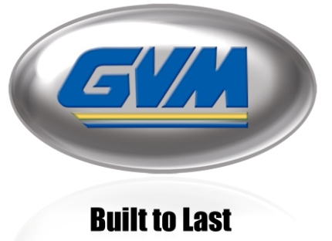
FOR IMMEDIATE RELEASE

THE ALL NEW E-SERIES
Building on Success, GVM Replaces Last Year’s E350 with Three New Models

Biglerville, PA (USA) – June 15, 2010 – Last August, GVM released the E350 Prowler, a machine that featured our largest capacities yet, an all new Variable Coil Spring Suspension, a larger cab, AgriWAVE® by AgJunction® and provided more power to the ground.

This year, GVM is replacing the E350 Prowler with three new E-Series Prowler models: the E370, the E325 and the E275. All models will feature the same, forward-mounted, Air Ride Cab with floor to ceiling glass, 32 inches of crop clearance and a Variable Coil Spring Suspension. The new models also feature the same electronic monitoring system providing machine diagnostic and gauges on a simple touch screen and AgriWAVE by GVM AgJunction.

The E370 Prowler gets its name from its large, 350 horsepower engine featuring a power bulge to 370 horsepower and is 11 ton dry capacity (1800 gallon liquid capacity). This model has a Cummins Tier 3 QSL8.9L 350 hp engine, a Funk DF250-11 speed electric bump-shirt transmission with torque converter lock up and proportional differential.

The E325 Prowler has a slightly smaller engine, using a Cummins Tier 3 QSL8.9L 300 horsepower with a power bulge to 325 hp and the new ZF 6WG210-6 speed power shift transmission with torque converter lock up and proportional differential. This model also has a large, 11 ton dry and 1800 gallon liquid capacity.

The E275, built with a Cummins Tier 3 QSB6.7L 275 horsepower engine and the new ZF 6WG210-6 speed powershift transmission with torque converter lock up and proportional differential and WB 158”, this model features the smallest engine in the E-Series line-up. Its chassis is also shorter to provide better maneuverability and while it can still handle an 11 ton capacity, it features a 9.5T dry body and 1600 gallon liquid tank.

The E-Series line-up will be displayed and ready for ride and drive at the MAGIE show and GVM’s Indiana, Ohio, and Pennsylvania Field Days and machine demo’s are available upon request.

Media Contact:
Contact: Erin Hutchison, Marketing Director
800-345-3546 x 260
eeh@gvminc.com
www.gvminc.com

