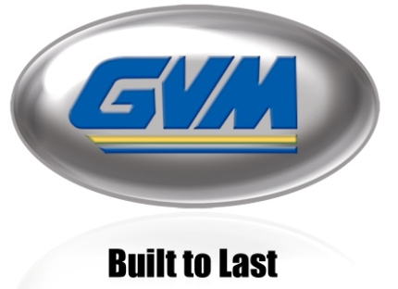
FOR IMMEDIATE RELEASE

GVM Inc. Announces New T325 Prowler

Biglerville, PA (USA) – September 25, 2019 – GVM Incorporated recently introduced its newest addition to its manufactured line of custom application equipment, the T325 Prowler, at the 2019 Midwest Ag Industries Expo in Bloomington, Illinois.

The T325 was designed from the ground up, realizing that our customers are our most valuable resource, the GVM team listened to their wants and needs, and designed a machine that was powerful, and ultimately cost effective. Designed with your bottom line in mind.

The T325 Prowler offers the first manufactured Stage V engine with a 325 hp rating, technology that is unparalleled in the industry - a more reliable machine with higher emission regulations and ultimately, a bigger return on your investment by reduced fuel consumption. It has an electronic monitoring system that displays machine diagnostics and gauges on a simple monitor.

GVM will begin production on the T325 Prowler in late September. For more information on GVM and the T325 Prowler, please visit www.gvminc.com .
About GVM Inc.: With over 40 years in business, GVM is a well-trusted manufacturer of agricultural application equipment headquartered in Biglerville, Pennsylvania. Their products include the Prowler, Double Duty, Mako, Hydra Spray and Multi-Grip Tire Handler.

Media Contact:
Ashley Light
800-458-5123 x229
anl@gvminc.com
www.gvminc.com

